- Intro
Chicago’s Department of Business Affairs and Consumer Protection provided monthly reports of all taxi trips in 2019. The dataset is filtered to use the first quarter of 2019 with 3343 observations. It consists of the following attributes: date; daytype (weekday or weekend); fare; tip; payment type (cash or credit); travel distance in miles; travel duration in seconds; speed in mph.
We will look at whether taxi fare amounts are predictable given the distance traveled, duration spent, and speed traveled. This supports making a future prediction of the impact of any predicted variable change on total city cab fares. This analysis helps understand how operational factors such as trip distance and duration influence taxi pricing, which is useful for both city regulators and riders.
We will also look at tipping. Since tips are not recorded if a customer used cash, we will only look at the customers with a recorded tip. We would like to test if the mean common US average tip etiquette of 15% is the same or different.
- Multiple Linear Regression
To understand what drives the taxi fare amount. We started by fitting a multiple linear regression model. We aimed to understand how the fare relates to the distance, duration, and speed as predictors. Figure 1 shows the model equation as fare_hat = 7.62 + 3.03distance + 0.00082duration - 0.22speed. For a one mile increase in distance, the estimated fare increases by $3.036, holding duration and speed constant. For a one mph increase in speed, the estimated fare amount decreases by $0.22, holding distance and duration constant.
We also included the Variance Inflation Factor (VIF) test to determine if we have some multicollinearity between our predictors since speed is derived from distance and duration (speed = distance/duration). Looking at the result from the model, our overall model fit R² adjusted is 0.8634. About 86.34% of sample variation in the taxi fare amount can be explained by a linear relationship of the taxi fare amount as a function of distance, duration, and speed.
The overall model hypothesis test has a null hypothesis that distance, duration, and speed have no linear relationship with fare. The alternative hypothesis is that at least one of these variables is associated with fare. The model’s F-value is 7043.82 and p-value is less than 0.0001. We reject the null hypothesis and conclude that there is statistical evidence that at least one of these variables is associated with fare.
Then looking at the variables independently, the null hypothesis would be that the beta variable equals zero and the alternative is that the beta variable does not equal zero. All of the variables have a p-value less than 0.0001. Thus there is statistical evidence that each individual variable is significant.
While statistical significance can sometimes be affected by multicollinearity, the VIF for all predictor variables is below 5, suggesting that multicollinearity is not a serious concern in this model. Therefore, the coefficient estimates are considered reasonably stable and reliable for interpretation.
Figure 2 shows that the assumptions are not met. Linearity assumption is not met since the points are not randomly scattered. Constant variance assumption is not met since the points are not evenly spread out and there may be heteroscedasticity. Normality is not met since the points on the Q-Q plot plot deviated from the diagonal, especially in both tails. Lastly, our data shows some highly influential outliers. One point had a leverage of 0.8. This model violates key assumptions and may not be appropriate for inference. Looking more into the variables may help us fit a better model.
- Multiple Linear Regression with Transformed Variables
We created a histogram for the predictor variables (fare, distance, duration, speed) to see the distribution of the data. Figure 3 shows the distribution of fare, distance and duration are heavily right-skewed, with the normal curve fitting poorly. Speed shows less right-skewedness. To address that we applied log transformation on both dependent and independent variables to see if we can improve the model. Figure 4 shows the regression results. Since all the variables are right-skewed and exhibit fan-shaped residual patterns, this suggests that the scale of impact when changing a variable is a multiplicative relationship with fare rather than an additive one. The R^2 adjusted is 82.69% which is lower than the first multiple linear regression model. This decrease is expected, as improving model assumptions can come at the cost of slightly reduced explanatory power. The assumptions are still not met, but it did improve the constant variance assumption. Normality also improved. They still exhibit a mild fan shape, which is an improvement over the previous model. However, it introduced severe multicollinearity with VIFs exceeding 25,000 among the independent variables. This is extreme and destabilizing. This could affect the reliability of our regression coefficients since distance, trip duration, and speed are closely connected. For example, if a trip covers a long distance, it will typically also take more time, and speed is directly determined by both. This means that longer trips and time spent in traffic, such as construction season, are key drivers of higher fares. Because of this, the model struggles to determine whether fare increases are due to distance, time, or speed individually.
Therefore, we decided to use ridge regression to help minimize the multicollinearity effect. We started by fitting ridge with all the log-transformed variables and gave ridge k values from 0 to 0.005, increasing by 0.001, see figure 5. Proc print outputted the ridge regression parameter estimates table showing lambda, RMSE, and parameter estimates. Lambda 0.002 is the best one to use because it provides a balance between reducing multicollinearity and maintaining a low RMSE (0.31022). The final model is ln(fare)_hat = -0.6542 + 0.3ln(Distance) + 0.49ln(Duration) - 0.06ln(Speed). This is a better model than the multiple regression model that we tried earlier.
Looking at the VIF for log(fare), at lambda = 0.002 the VIF of the distance dropped to 3.09, where VIF < 5. The standardized coefficient confirms that estimates were driven by multicollinearity rather than real relationships. From our table output, lambda = 0.002 had lower RMSE among values where VIF fell below 5. Therefore, it was selected for our ridge k-value giving us a ridge model that we can use to predict the fare amount.
Then we changed the ridge value to 0.002 and included outseb in the proc reg line to get the standard error for each parameter estimate, see figure 6. The standard errors are small relative to the magnitude of the coefficients, suggesting that the estimates are reasonably stable after applying ridge regression. The RMSE is 0.30594 which is good because it indicates that the model's predicted values are closer to the actual, observed data points. The final equation is ln(fare)_hat = -0.6542 + 0.29999ln(Distance) + 0.48715ln(Duration) - 0.06053ln(Speed). The final model suggests that a 1% increase in distance is associated with approximately a 0.30% increase in fare, holding other variables constant. Similarly, a 1% increase in trip duration increases fare by about 0.49%, while speed has a small negative relationship with fare. The negative relationship with speed may reflect that higher speeds are associated with less congested trips, resulting in shorter durations and therefore lower fares. In future analysis, we will look at the model without including speed as a predictor variable. We include it now for completeness.
- Predictability Verification
To validate predictive performance, we check the prediction table in figure 6 to see how close the prediction value is to the actual one and if they all fall within their respective 95% prediction intervals. For example, taking observation number 8, first we need to exponentiate the model's log fare back to the original dollar scale. Actual fare amount = $e^{3.04} = \$20.90$; predicted fare amount = $e^{2.9792}= \$19.67$; which is very close to the actual value. This falls within 95% CI predicted (2.3791, 3.5793) = ($10.79, $35.84). This demonstrates that the model provides reasonably accurate predictions on the original dollar scale.
- Student’s T-Test Analysis
We wanted to see when customers tip, do they tip the common average tip etiquette of 15% or is it different. We previously graphed the distribution of tip percentage. The average tip percentage is 15.98% and standard deviation is 4.24%, see figure 7. To validate this tip percentage, we had a null hypothesis that the mean tip percentage is equal to 15%. The alternative hypothesis was the mean tip percentage was different than 15%. Using the Proc Ttest method where H0=0.15 and filtered on only customers with a recorded tip, we have a t-value of 9.3 and p-value < 0.0001, see figure 8. So we reject the null hypothesis (H0) and conclude there is strong statistical evidence that the mean tip percentage for customers who tip is different from 15%.
The assumptions for the two-sided t-test are met. The normal curve of the distribution of tip percentage fits the data well. The highest bar shows about 30% of observations fall within that range around 15%. The Q-Q plot shows almost all of the points fitting the line. The assumptions are met and in the future we would like to do a one-tailed, upper test to see if the mean tip percentage is greater than 15%. As a practical tip consideration, cash tips are not recorded or available, which suggests that cash tips may be at a higher percentage.
Then we looked at when customers tip, do they tip the same on the weekday vs the weekend or is it different. Using the Proc Ttest method with class day type and filtered on only customers that tip, the equality of variance has a F value of 1.03 and p-value of 0.6618, see figure 9. Since the p-value is greater than alpha=0.05, the difference in variances is not significant and will use pooled variance. The pooled variance has a t-value of 0.4 and p-value of 0.6918. We fail to reject H0 and conclude there is no statistical evidence that the mean tip percentage for customers who tip is different between weekdays and weekends. The assumptions are met. The histograms show the data fitting the normal curve. The Q-Q plots show the data fitting the line.
- Conclusion
Duration and distance are the primary drivers for Chicago cab fare amounts. Speed was considered, but its individual effect is difficult to interpret due to multicollinearity. Ridge was the best model at lambda = 0.002, since the predicted values are closer to the actual, observed data points. In the future, we will remove the predictor variable speed to see how distance and duration predict fare amount. From a practical standpoint, cab fare is cost driven: primarily driven by trip distance and duration, which are the key factors influencing cost which makes the impact of rate changes predictable.
Mean tip percentage is statistically significantly different from the common average tip etiquette of 15%. In the future, we will look to see if the mean tip percentage is greater than 15%. Also there is no statistical evidence of a difference to the tip percentage between weekday and weekend fares.
These findings may be useful for the City of Chicago in understanding factors that influence taxi fares and evaluating fare structures. From a driver’s perspective, since no significant difference in tipping behavior was found between weekdays and weekends, tip percentages appear to be relatively consistent across day types. However, tipping behavior is likely influenced by multiple factors beyond fare alone, so increasing fares alone does not necessarily guarantee higher tips.

Appendix
Figure 1
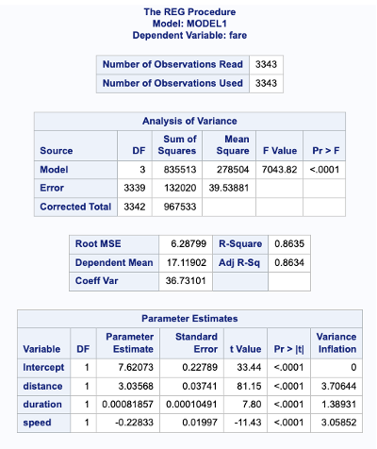
Figure 2
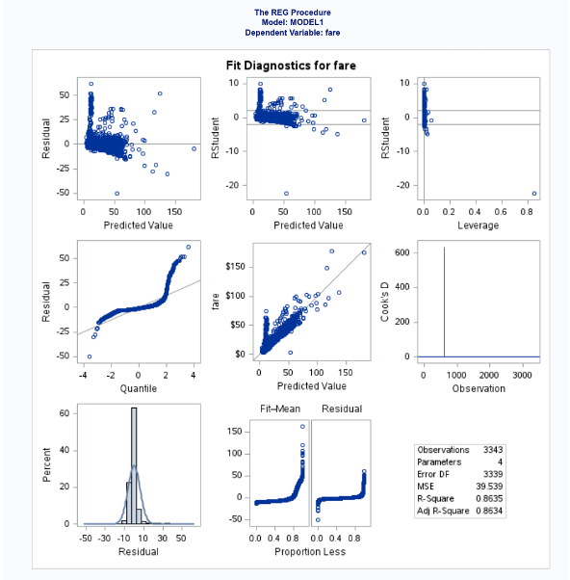

Figure 3

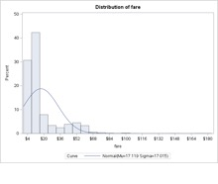 | 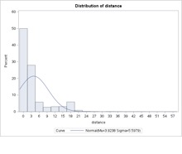
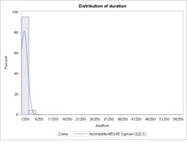 | 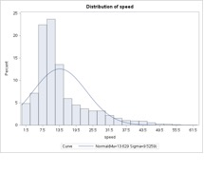
Figure 4
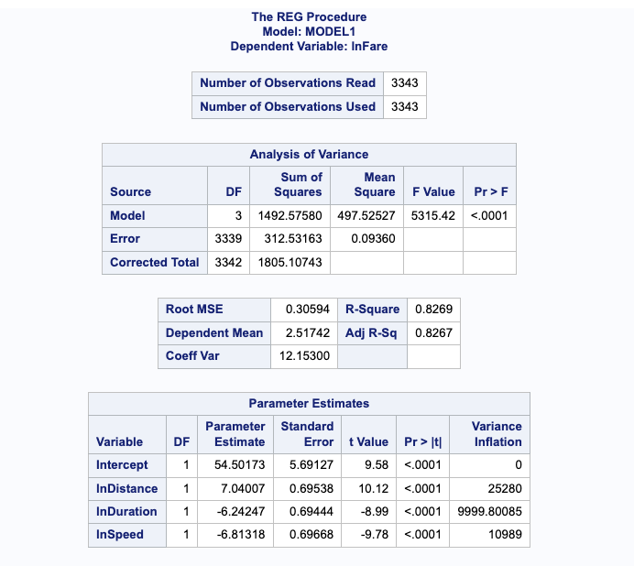
Figure 4


